

# FSM - Prominent

|  |  |  |
| --- | --- | --- |
| **Supervisor:** | *LÊ THANH NHÂN* |  |
| **Semester:** | *II* |  |
| **Batch No:** | *T1.2011.M0* |  |
| **Group No:** | *04* |  |
| **Order:** | **Full name** | **Roll No.** |
| *1.* | *PHAM THIEN LONG* | *Student1285597* |
| *2.* | *BUI DAI THANG* | *Student1281546* |
| *3.* | *NGUYEN THI ANH THU* | *Student1286315* |
| *4.* | *TRAN TRUNG NGHIA* | *Student1286083* |

***Month****: 9* ***Year****: 2021*



This is to certify that

|  |  |
| --- | --- |
| **Mr.** | **PHẠM THIÊN LONG** |
| **Mr.** | **BÙI ĐẠI THẮNG** |
| **Mrs.** | **NGUYỄN THỊ ANH THƯ** |
| **Ms.** | **TRẦN TRUNG NGHĨA** |

Have successfully Designed & Developed

**FSM - Prominent**



Submitted by:

**Mr. LE THANH NHAN**



Authorized Signature:



**Contents**

Table of contents

- Acknowledge ………………...(page )

- Synposis ………………...(page )

**Review1** ………………...(page )

- Problem Definition ………………...(page )

- Customer Requirements Specifications ………………...(page )

- Task Sheet Review 1 ………………...(page )

**Review2** ………………...(page )

- Data Flow Chart ………………...(page )

A. DFD (page )

B. ERD (page )

A. ERD Properties (page )

- Table Design ………………...(page )

A. Table of database (page )

B. Relationship of tables (page )

- Algorithm ………………...(page )

A. Admin (page )

B. User (page )

**Acknowledge**

First of all, our group of 4 would like to thank everyone who has supported and helped the group during this time in this project.

First of all, we would like to thank the person who guided and guided us during the implementation of this thesis, Mr. Le Thanh Nhan, who not only enthusiastically guided our knowledge and encouraged us when we were working on this project. having difficulty in learning, but he was very tough so that we have a good and acceptable working style. complete and complete.

Next, we would like to thank FPT-Aptech Academy for always helping and creating the best conditions for us to apply our knowledge in real projects. In addition, the teachers and brothers and sisters of the school are also extremely enthusiastic when we have difficulties and always answer questions as quickly as possible.

The last word I want to send to my classmates, brothers, and sisters who have always accompanied and helped in learning in an extremely open and enthusiastic way.

Your Sincerely, Team Group 04.

**Synposis**

The life of the internet is the farewell of people, everything in life gradually becomes more colorful, convenient, and faster thanks to it. As everyone knows, the whole world is having a common "war" with the covid-19 pandemic, so moving to the street has been extremely difficult, including shopping. But thanks to the internet it has become so much easier with just a few clicks we can buy whatever we need.

So shopping websites took advantage of that and grew very quickly, including fashion store websites. Thanks to that, they easily promote their brand and attract more potential customers thanks to this form, so the revenue has increased significantly.

FSM - Prominent, a small fashion store, has noticed this trend. Therefore, they asked us to create a website so that people can easily order the items they love without having to go out to the store in person. Moreover, the company wants to Get customer feedback to improve our service better and better.

In addition, our team designed a system that can manage products (update, delete or search…) and track customer orders.

# Review 01

## Problem Definition

These days in the hustle and bustle of people's lives, taking time to go out to shop has become a luxury. Worries about unsafe traffic and restrictions on traditional purchases avoidable while shopping online. With online shopping, you don't have to worry about weather conditions either. Consumers and customers who are organizations, companies, etc. are gradually turning to online shopping to save time.

That's why online shopping becomes more and more important and necessary. With just one click, they can get the product they want. Online shopping has many advantages that you can own everything. through mouse clicks rather than going to the place to buy. After going to the sales website, choose a product, just place an order (order) and the seller will bring the product to your home. Online shopping allows you to shop whenever you want. Online stores never close, can shop 24/24 hours and 7 days a week. Shopping in markets, malls or stores is difficult for you to compare the characteristics and prices of products with each other. When shopping online, you can easily compare and choose the most suitable product. Sometimes you run into difficult salespeople at certain sales locations. Online shopping, customers do not have to pay attention to that anymore. Therefore, FSM – Prominent based on the above criteria has developed a website so that customers can trust and shop comfortably without having to think much. Saving your cost, time and effort is our top priority.

**The Role of User and Admin:**

FOR CUSTOMER’S SITER

* The homepage will give a brief introduction of the company, also design a suitable logo and put it on the homepage, you can display the logo on all the pages in the website
* A menu will include all the functions implemented in the website.
* A catalog should be provided to help visitors select and order desired products.
* The shopping cart will store the customer's order and send messenger gmail to confirm your orders
* The contact us page will show the address along with their location on the map.

FOR ADMIN’S SITE

* The login page will grant access to the our administrator or moderator.
* The admin management page will be used to insert, delete or update the categories , brands , products , … as well as track orders, account information and customer feedback.
* Management page for Moderator to insert, update, delete accounts of ministrators based on its executivesUser.

**Customer Requirements Specifications**

|  |
| --- |
| **USER:** |
| **Input:** |
| * - Member registration information. * - Login, logout * - View product’s information. * - Order selected products. |
| **Process:** |
| * - Search products from database by categories, by product types. * - Process customer registration information. * - Process product’s feedback. * - Process customer orders. |
| **Output:** |
| * - Notification of successful registration / failure. * - Product information. * - View bought history. * - Notification of successful making order order. |

|  |
| --- |
| **ADMIN:** |
| **Input:** |
| * - Administrator login information . * - Product – Brands - Category information to add / edit / delete. * - Member information to be search / disable or enable account. * - Order information to be search / approve. |
| **Process:** |
| * - Add / edit / delete products. * - View information of all members. * - Change member account’s status. * - View all orders. * - Update order status. |
| **Output:** |
| * -Notification to add / edit / delete products success / failure. * -Notification to change member account’s status. * -Notification to update order’s status.   **Note:** Constraint validation must be provided wherever necessary. And the website should have the smooth navigations.  **Hardware / software requirement:**   |  |  |  | | --- | --- | --- | | **Sr.** | **Item** | **Description** | | 1. | Operating system | Windows 7, 8, or higher | | 2. | Hardware | CPU Cores or better with 2 Gigabytes of RAM or better | | 3. | Web Browser | Version in later of: Edge, Firefox, Chrome, etc… | | 4. | Fonts | Standard font Unicode: Arial, Tahoma, Lucida Console, Times New Roman, etc… | | 5. | Other requirement | NodeJS, Git, XAMPP 7.3 or later | A working internet connection. | |

|  |
| --- |
| REVIEW 1 – TASK SHEET |

|  |  |  |  |  |  |  |  |  |
| --- | --- | --- | --- | --- | --- | --- | --- | --- |
| **No** | **Member** | **Contents** | | **Table Name** | **Activity Plan** | **Date of Preparation of Activity Plan** | | |
| **Planed Start Date** | **Actual Start Date** | **Actual Days** | **Status** |
| 1 | **Pham Thien Long** | Admin | *View , add , edit , delete category / barnd* | Danhmuc loaisanpham | 29/09/2021 | 04/10/2021 | 5 | OK |
| 2 | 29/09/2021 | 04/10/2021 | 5 | OK |
| 3 | User | *Register* | 29/09/2021 | 04/10/2021 | 5 | OK |
| 4 | *Change name , password* | 29/09/2021 | 04/10/2021 | 5 | OK |
|  |  |  |  |  |  |  |  |  |
| 1 | **Bui Dai Thang** | Admin | *View , add , edit , delete products in database* | sanpham | 29/09/2021 | 04/10/2021 | 5 | OK |
| 2 | 29/09/2021 | 04/10/2021 | 5 | OK |
| 3 | 29/09/2021 | 04/10/2021 | 5 | OK |
| 4 | User | *View Product* | 29/09/2021 | 04/10/2021 | 5 | OK |
|  |  |  |  |  |  |  |  |  |
| 1 | **Nguyen Thi Anh Thu** | Admin | *View , check order’s customer , processing order* | donhang chitietdonhang | 29/09/2021 | 04/10/2021 | 5 | OK |
| 2 | 29/09/2021 | 04/10/2021 | 5 | OK |
| 3 | User | Add Order | 29/09/2021 | 04/10/2021 | 5 | OK |
| 4 | *View information ordder* | 29/09/2021 | 04/10/2021 | 5 | OK |
|  |  |  |  |  |  |  |  |  |
| 1 | **Tran Trung Nghia** | Admin | *View , add , edit , delete customer* | nguoidung | 29/09/2021 | 04/10/2021 | 5 | OK |
| 2 | 29/09/2021 | 04/10/2021 | 5 | OK |
| 3 | User | *Register , login* | 29/09/2021 | 04/10/2021 | 5 | OK |
| 4 |  | 29/09/2021 | 04/10/2021 | 5 | OK |

# Review 02

## Data Flow Diagram

**A. DFD**

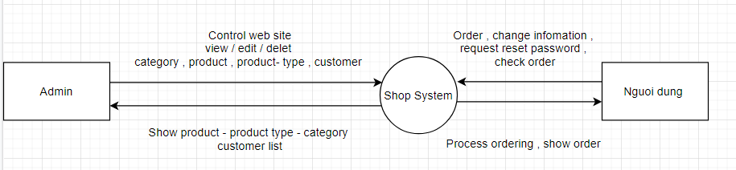

**B. ERD**

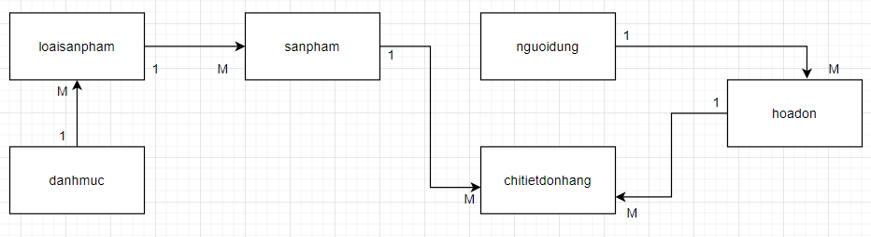

**C. ERD Properties**

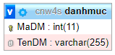

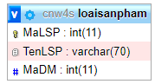

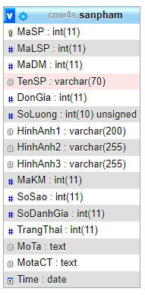

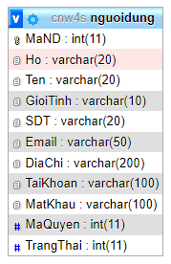

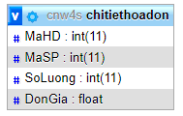

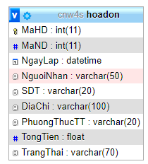

## Table Design

**A. Table Design**

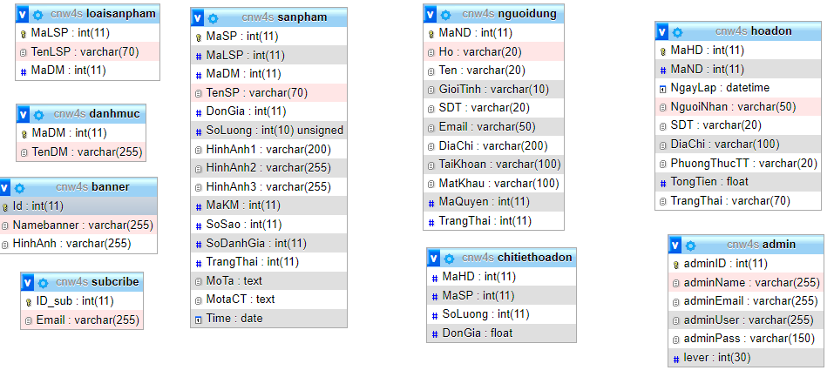

**B. Relationship Diagram**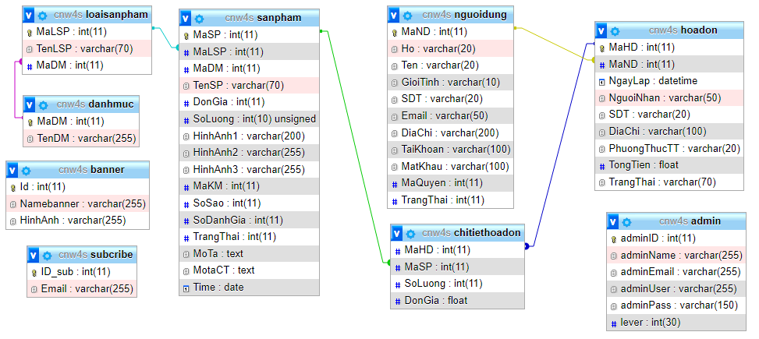

## Algorithm

**A. Admin**

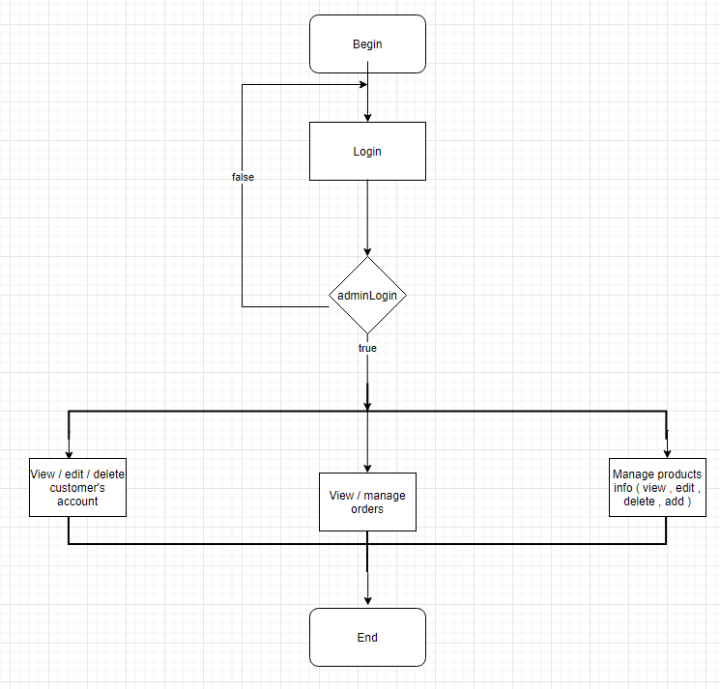

**B. User**

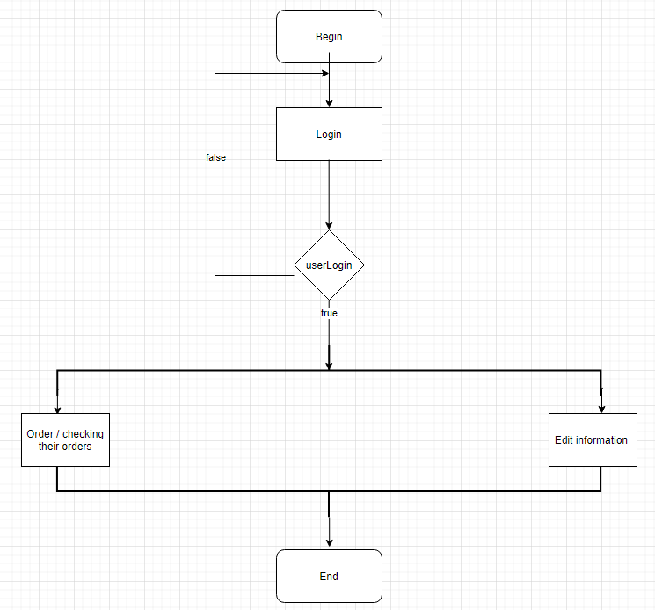

# Review 03

## Site Map

1. **Home page**

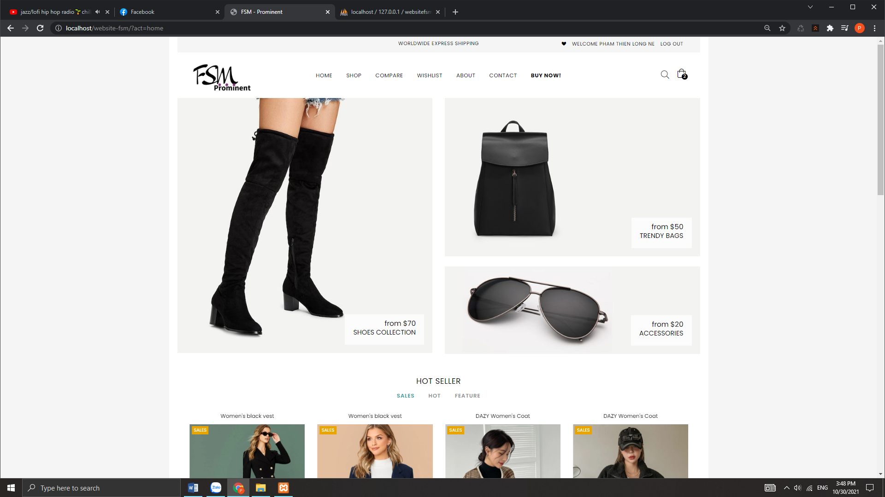

|  |  |
| --- | --- |
| Description | HomePage |
| From | N/A |
| To | Shop, My Account,Contact Us, About Us, Admin page |
| Event | Navigate the site by clicking menus or products. |

1. Shop

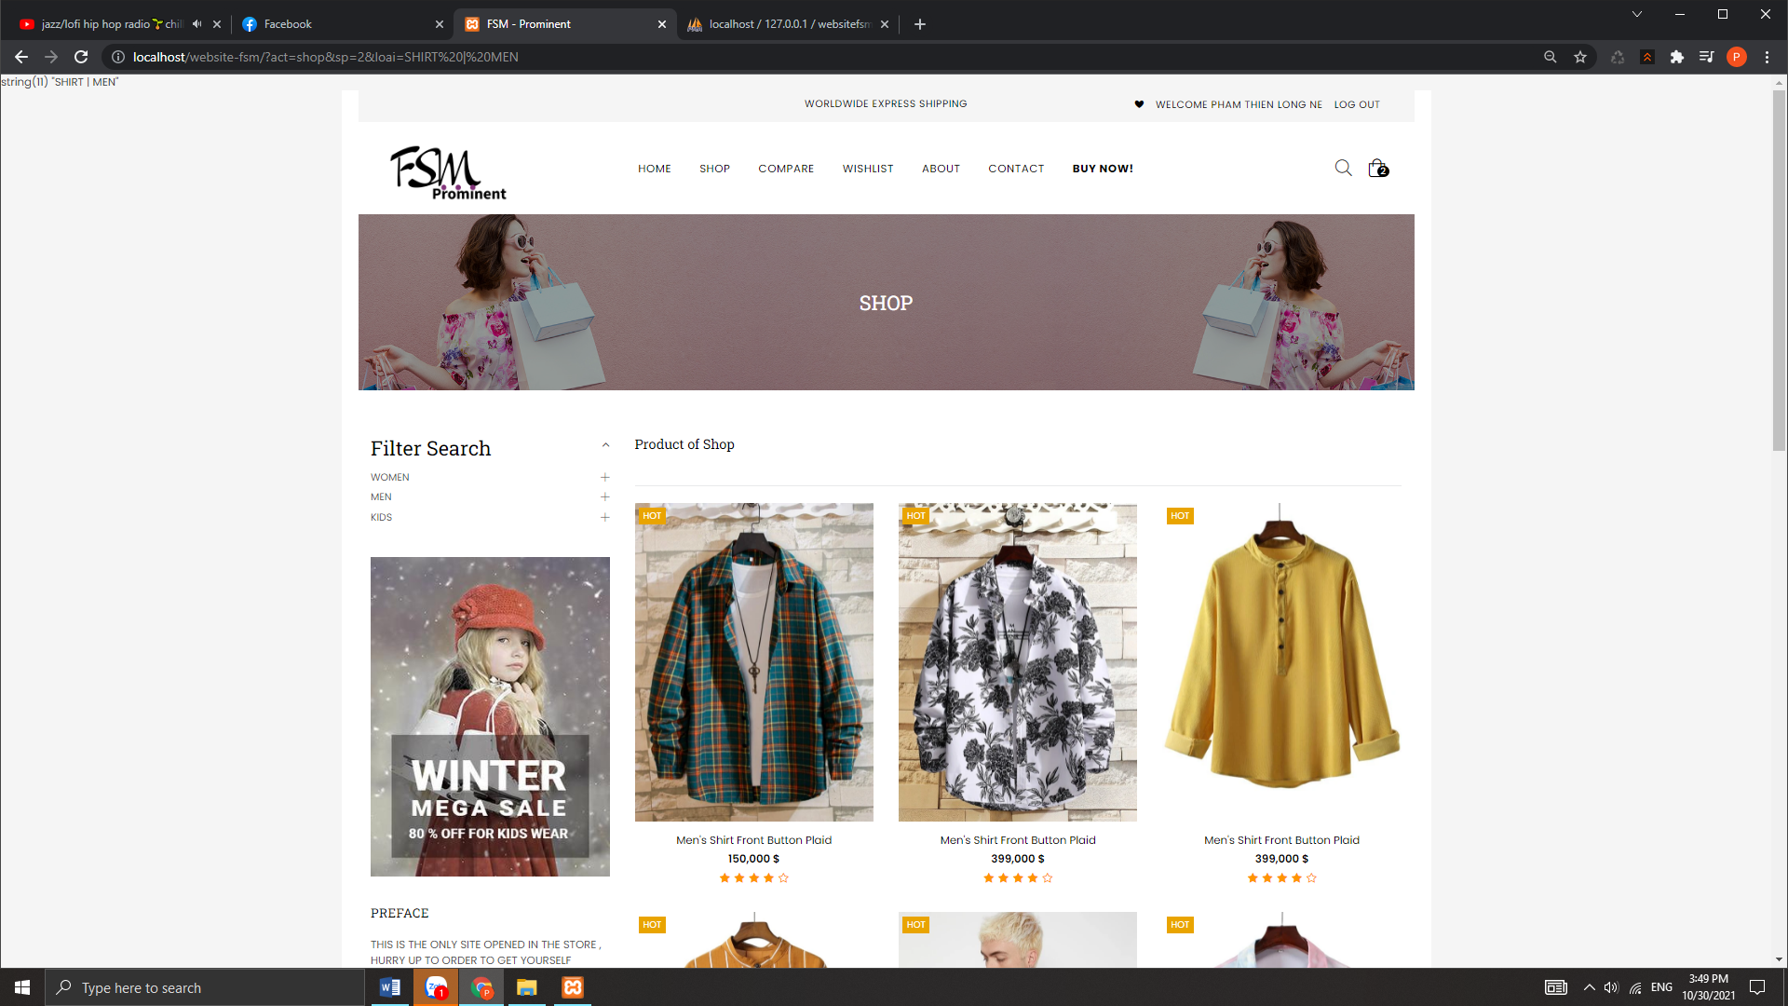

|  |  |
| --- | --- |
| Description | Shop Page |
| From | Home Page |
| To | Shop page |
| Event | Customers can view products by category, view details, search by product name. |

1. About us page

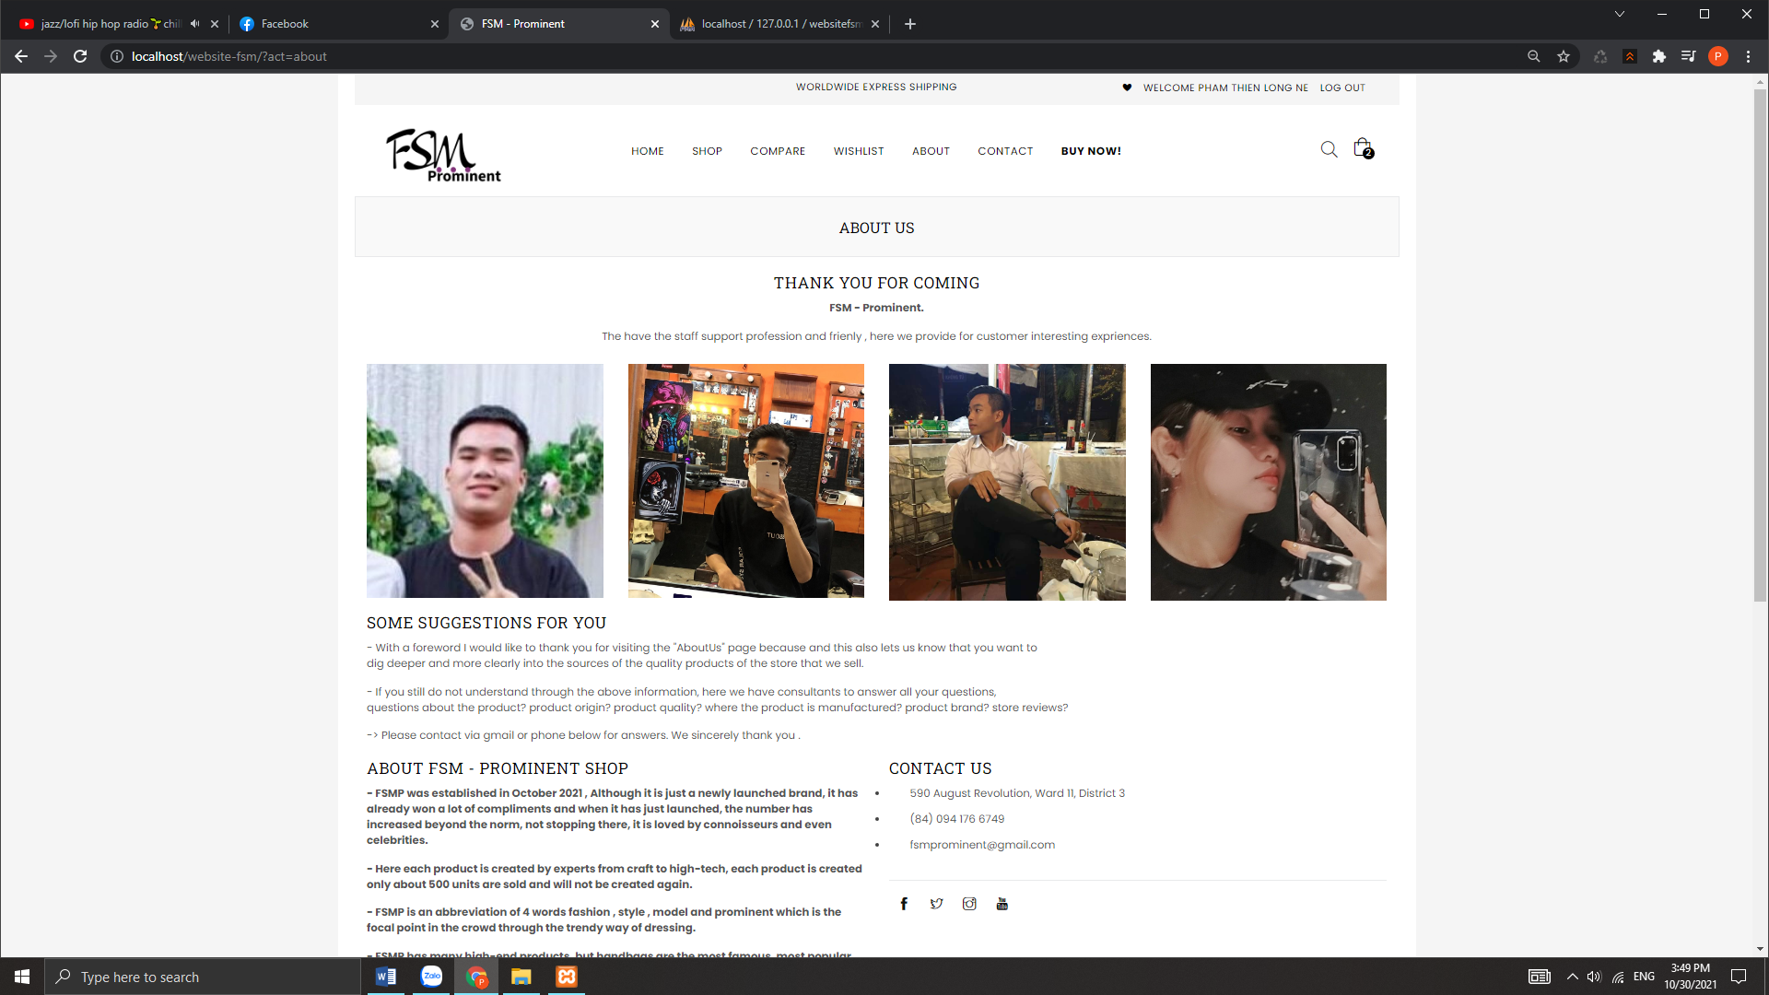

|  |  |
| --- | --- |
| Description | About Us Page |
| From | Home Page |
| To | About Us Page |
| Event | Show all information about the business including  including phone number 1, phone number 2, business address  correct business name, email, and address on Google  Map.  Show typical members who created the site. |

1. Contact us page

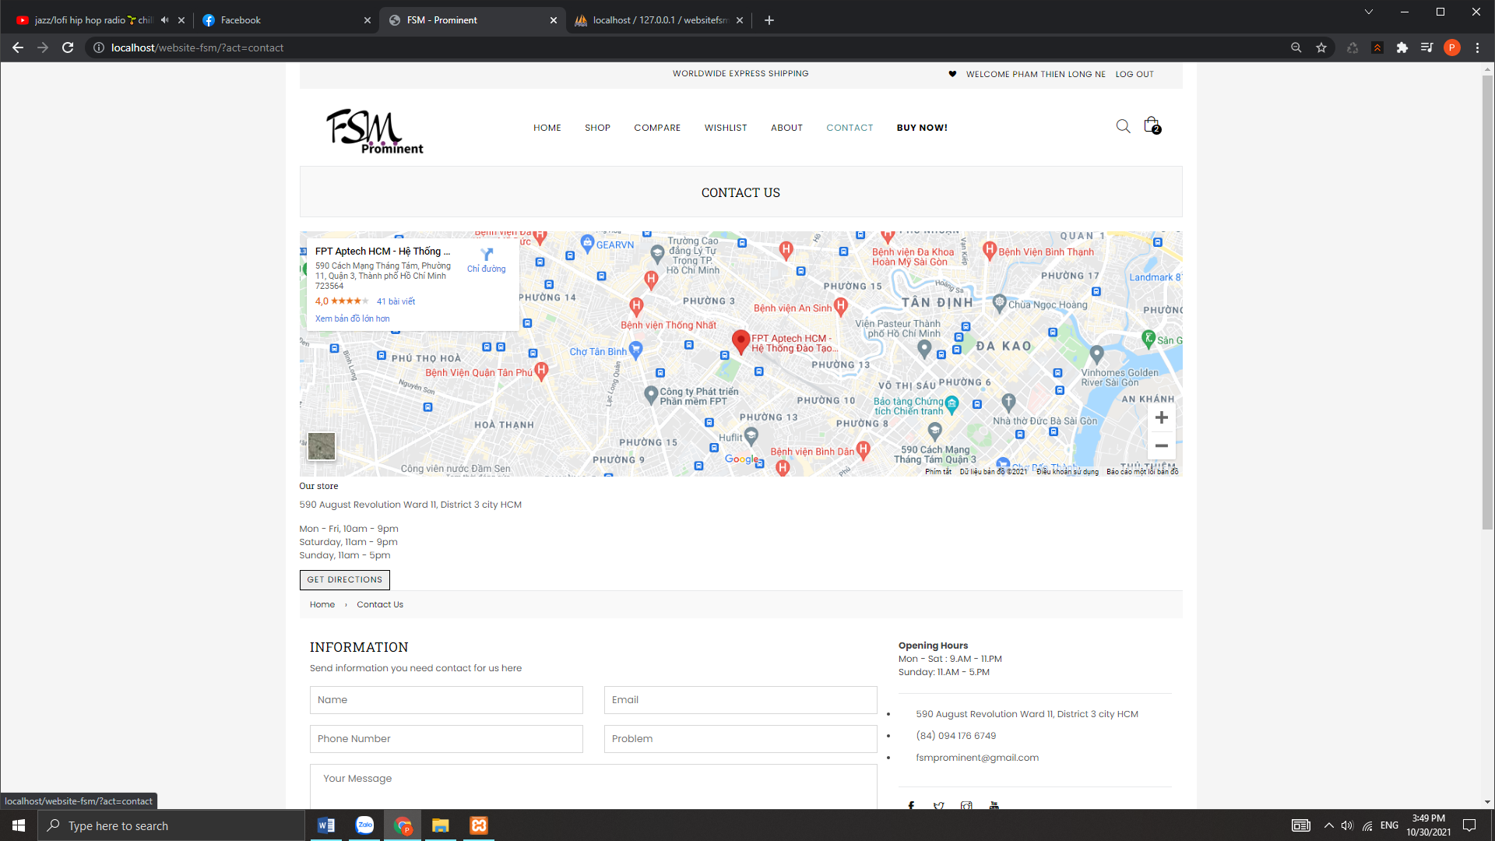

|  |  |
| --- | --- |
| Description | Contact Us Page |
| From | Home Page |
| To | Contact Us Page |
| Event | customer can send feedback to admin through form |

1. View cart

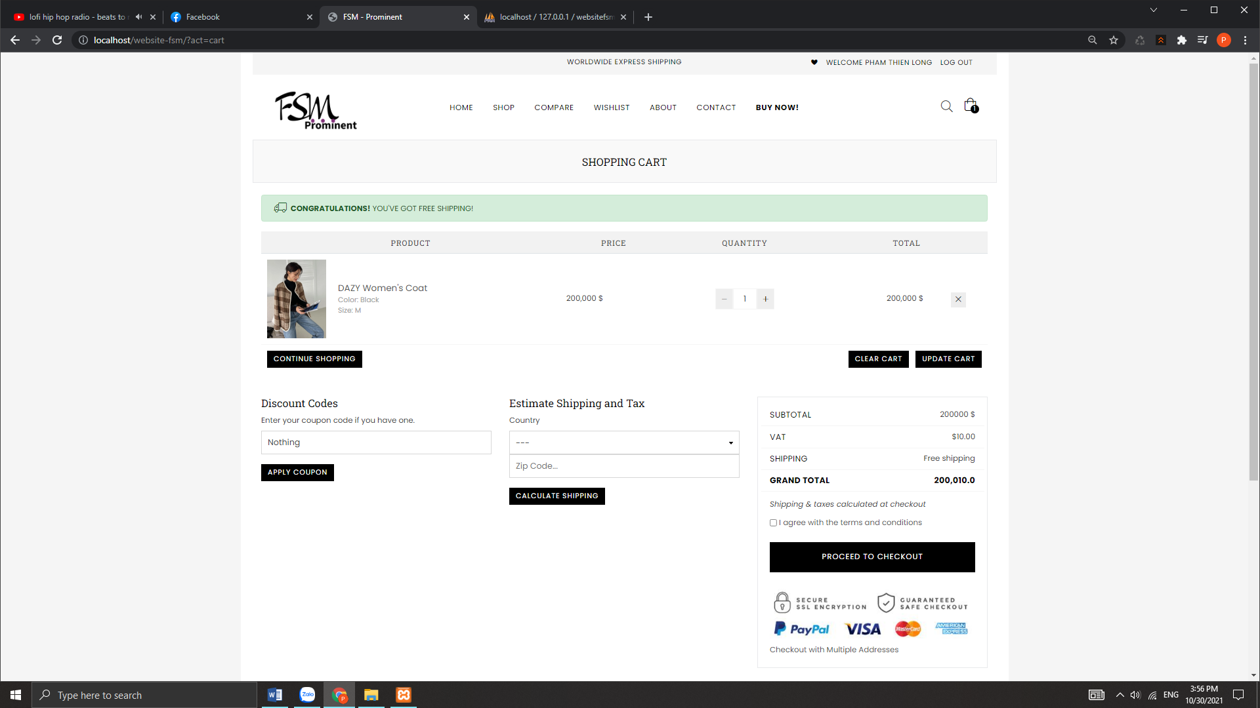

1. Check out

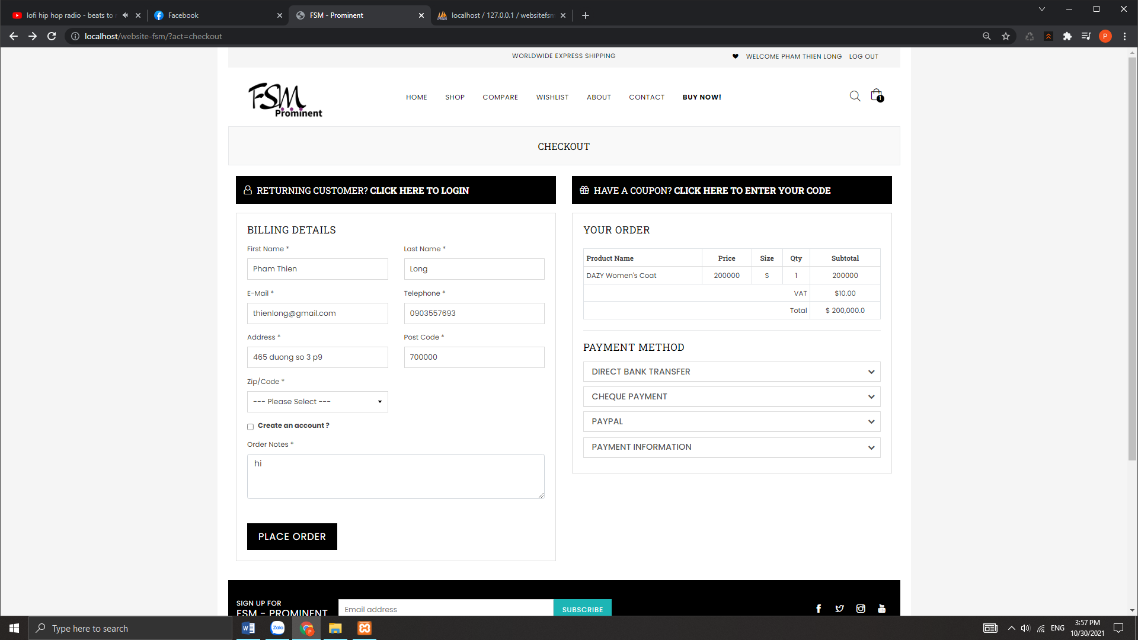

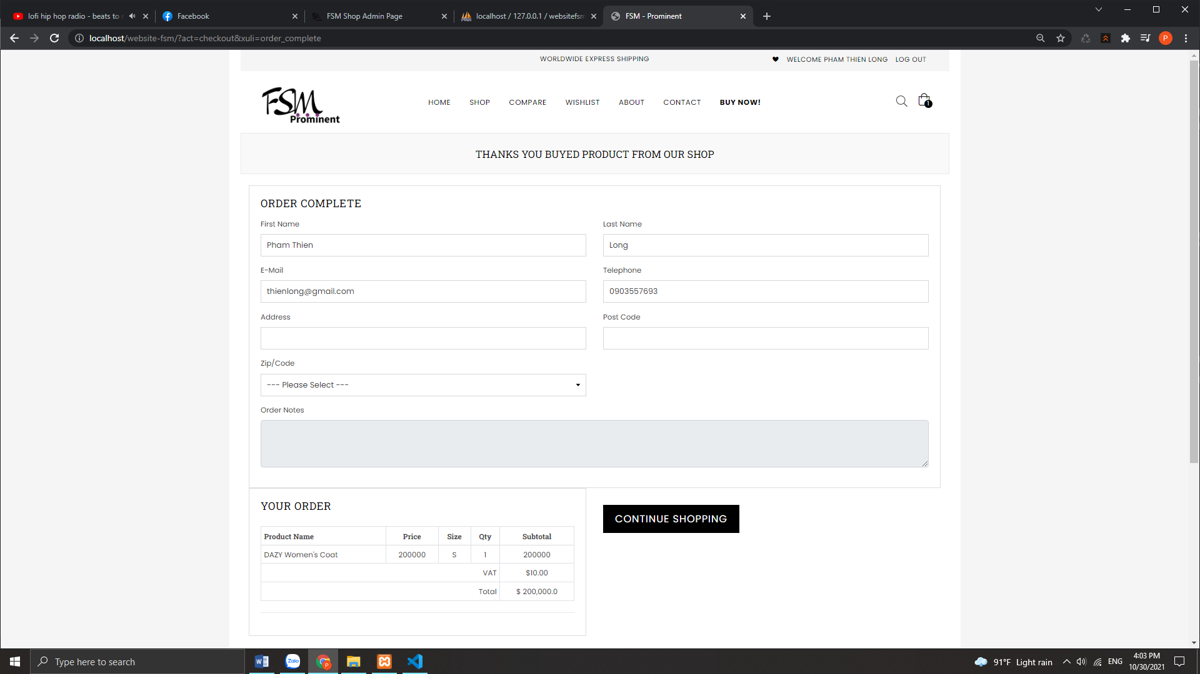

1. Admin Page

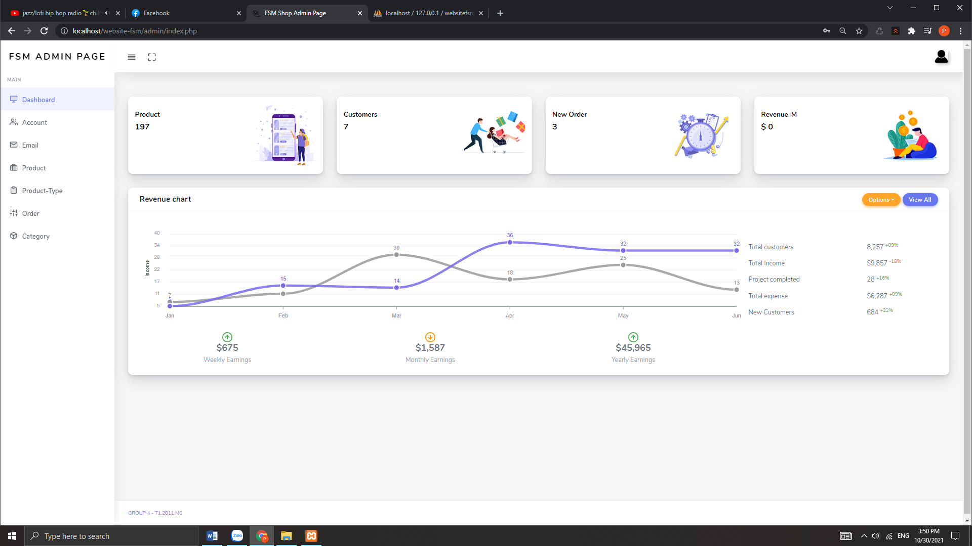

|  |  |
| --- | --- |
| Description | ADMIN Page |
| From | ADMIN PAGE |
| To | Customer page |
| Event | Admin can INSERT/VIEW/UPDATE/DELETE |

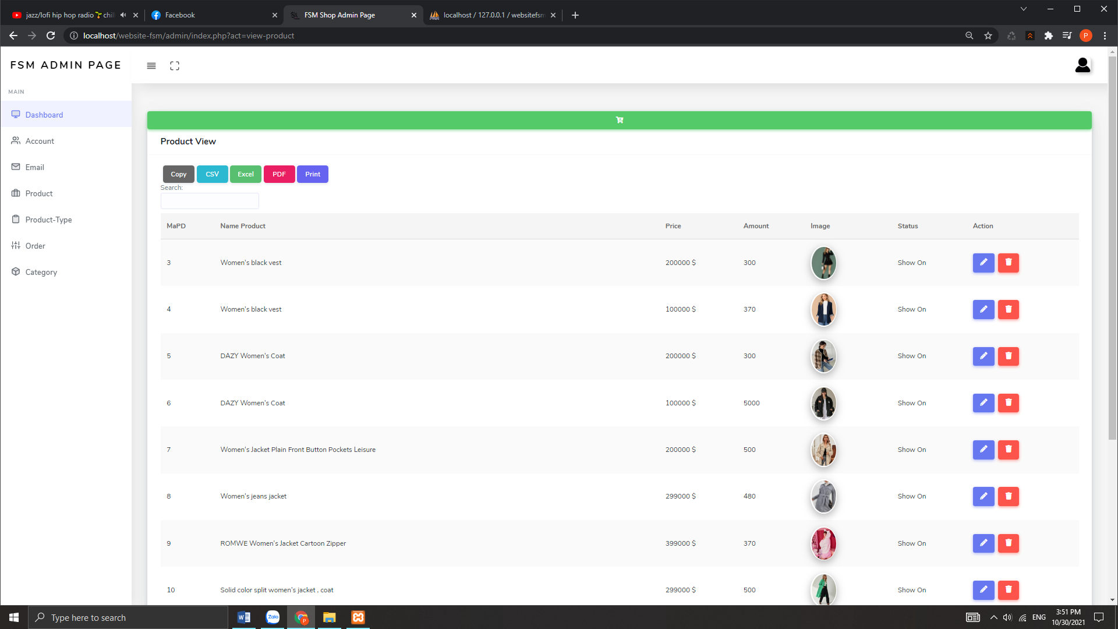

|  |  |
| --- | --- |
| Description | ADMIN Page |
| From | ADMIN PAGE |
| To | Product page |
| Event | Admin can INSERT/VIEW/UPDATE/DELETE |

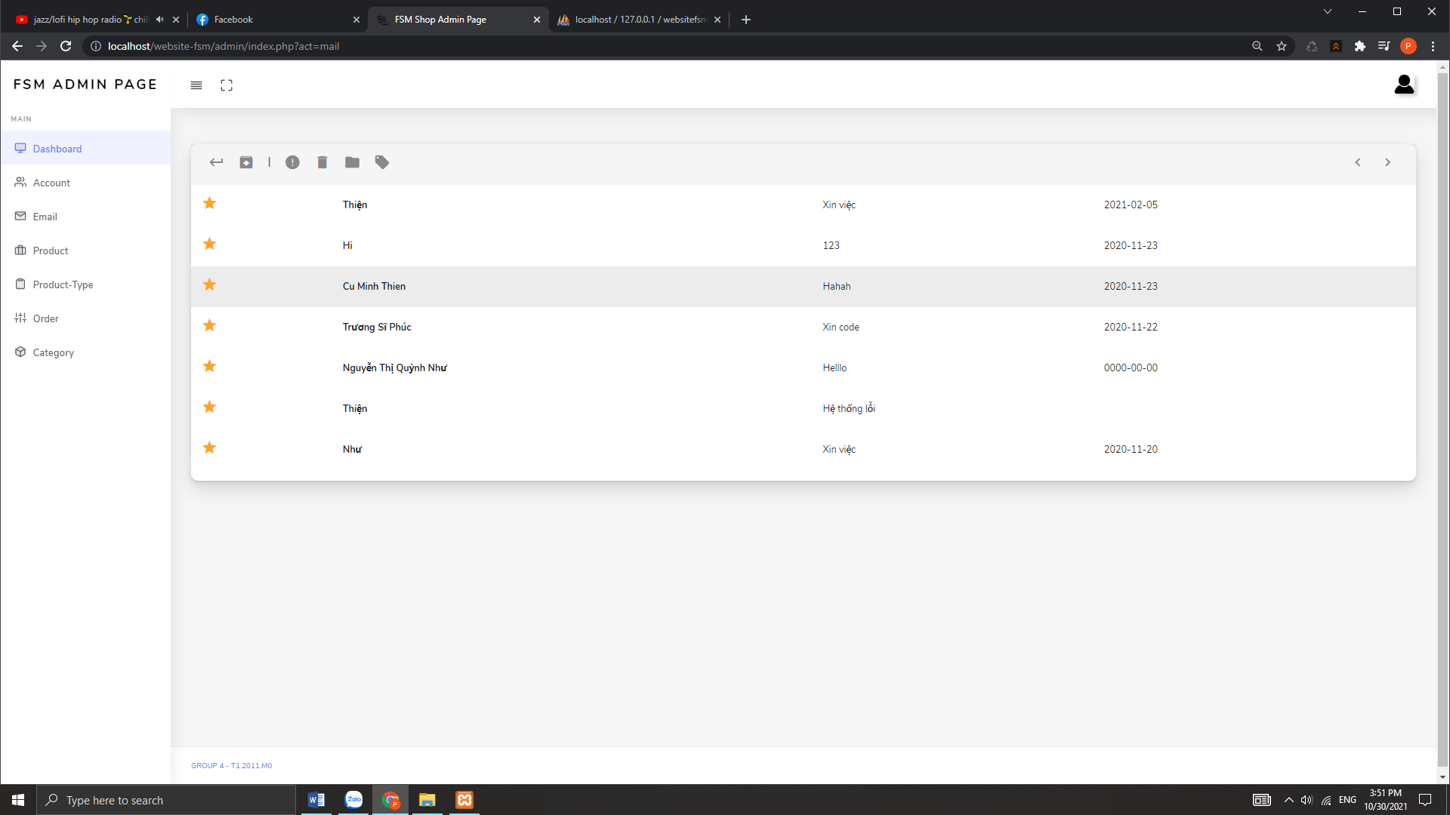

|  |  |
| --- | --- |
| Description | ADMIN Page |
| From | ADMIN PAGE |
| To | Mail page |
| Event | Admin can View , reply , delete |

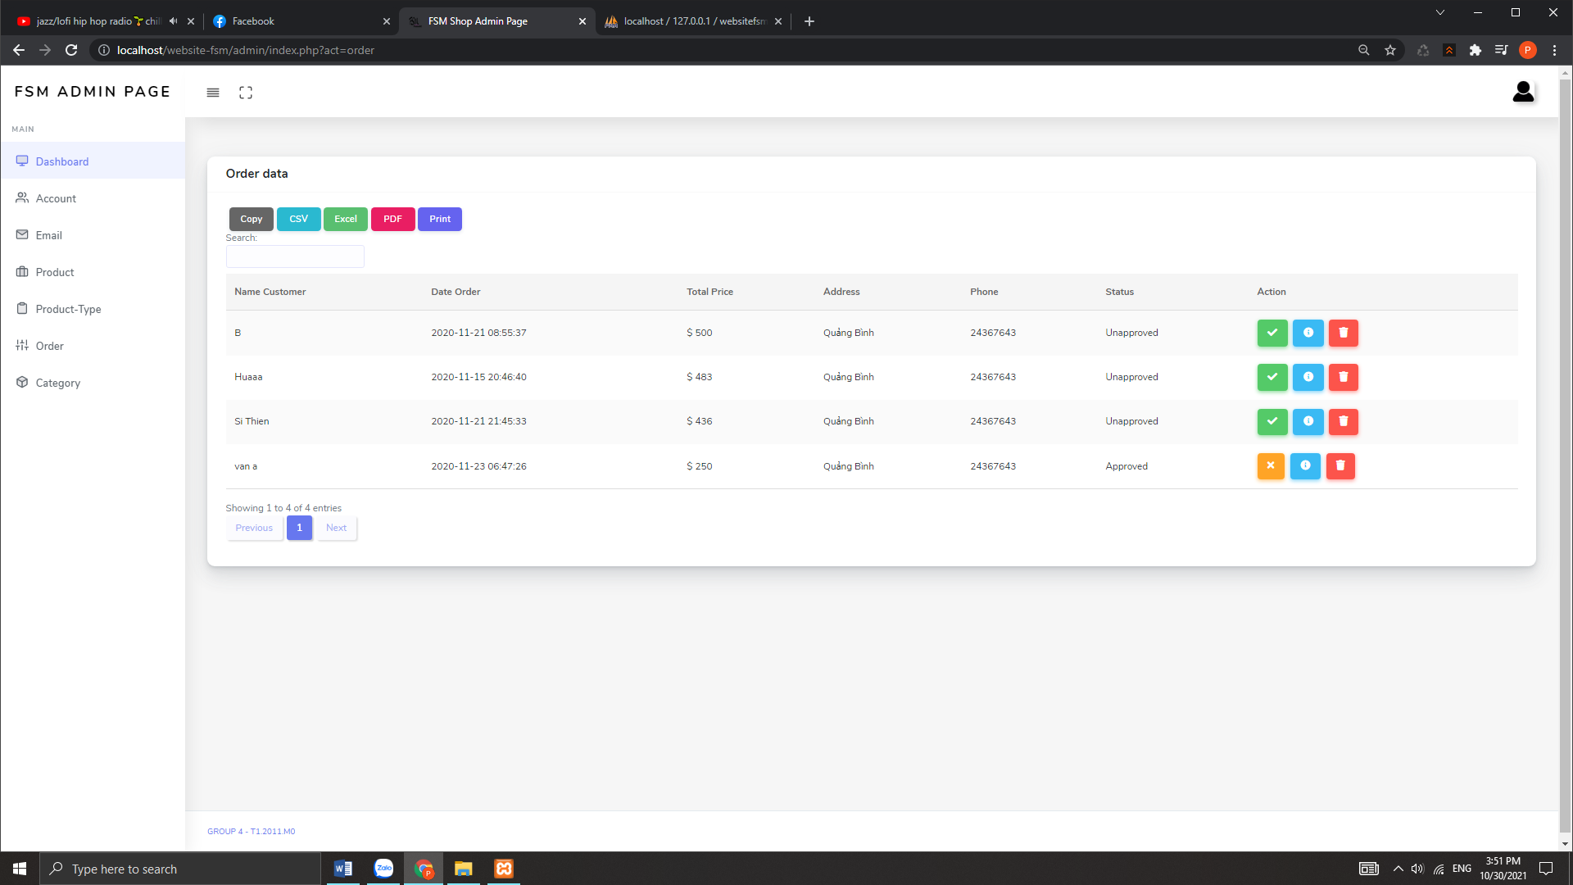

|  |  |
| --- | --- |
| Description | ADMIN Page |
| From | ADMIN PAGE |
| To | Order page |
| Event | Admin can View detail of order , process , delete |

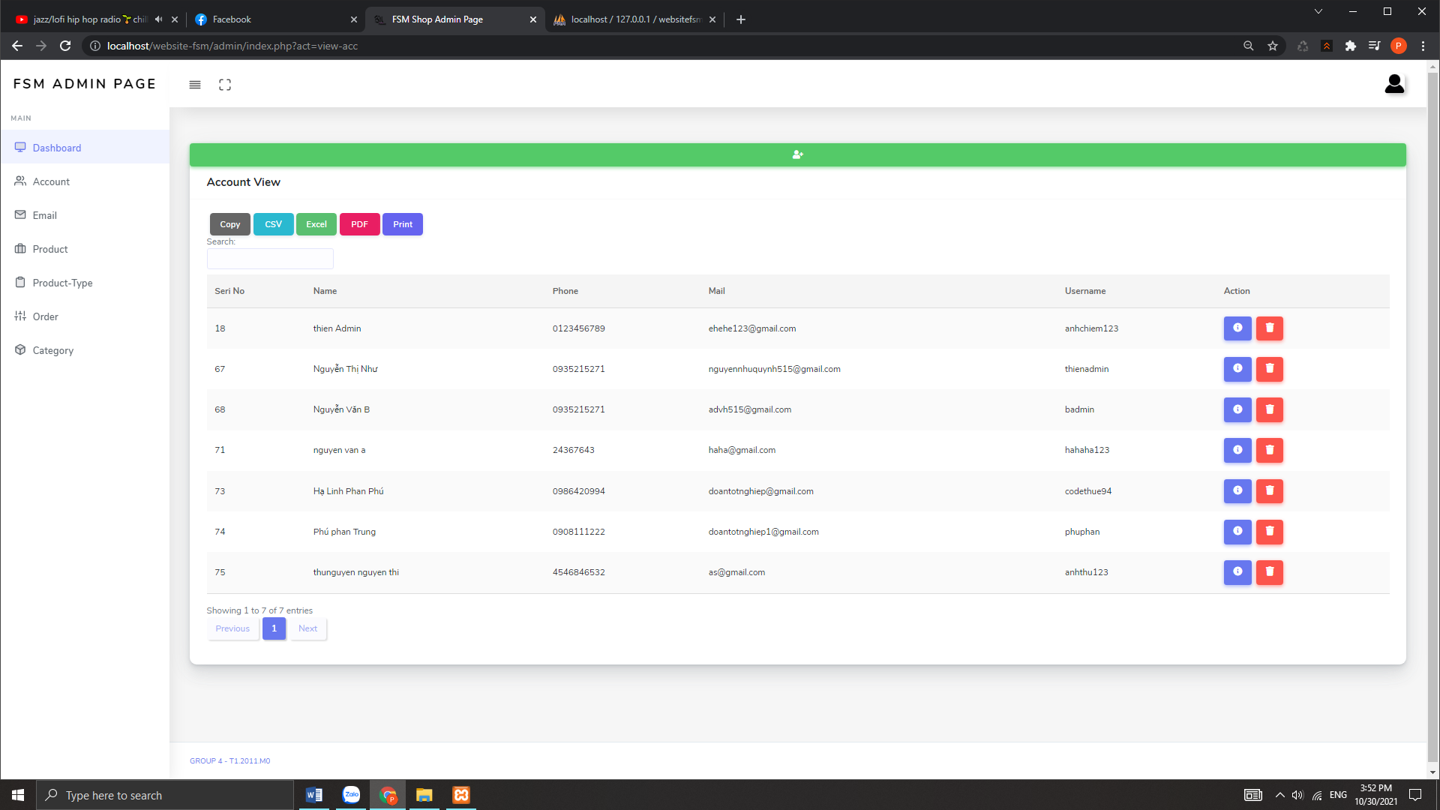

|  |  |
| --- | --- |
| Description | ADMIN Page |
| From | ADMIN PAGE |
| To | Account page |
| Event | Admin can View detail of order , process , delete |

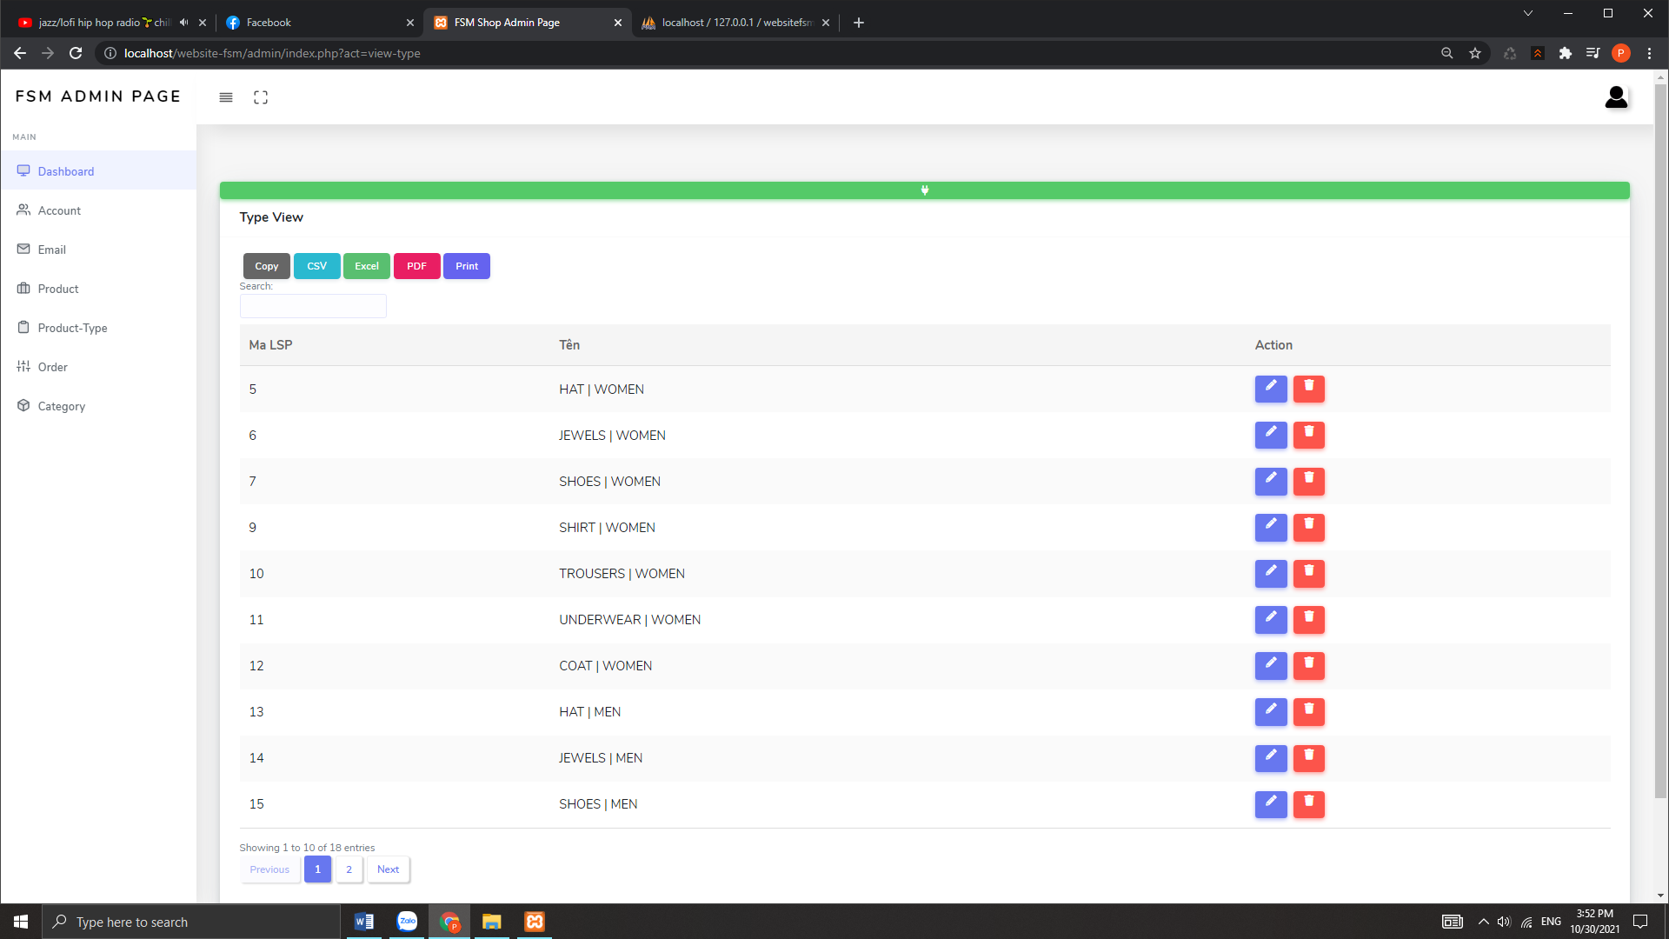

|  |  |
| --- | --- |
| Description | ADMIN Page |
| From | ADMIN PAGE |
| To | Product-type page |
| Event | Admin can View detail of order , process , delete |

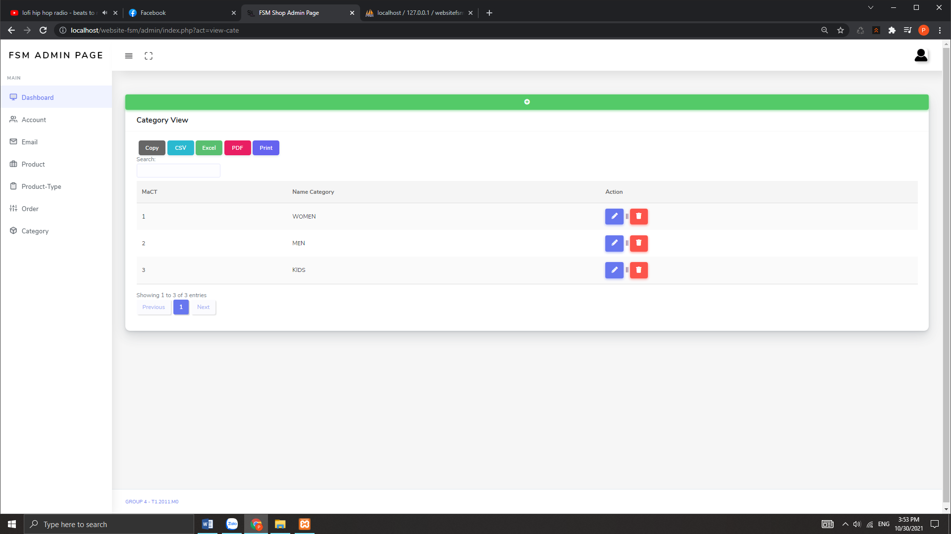

|  |  |
| --- | --- |
| Description | ADMIN Page |
| From | ADMIN PAGE |
| To | Category page |
| Event | Admin can View detail of order , process , delete |

TESTING DOCUMENT

|  |  |  |
| --- | --- | --- |
| **Sr.No** | **Features Tested** | **Remarks** |
| 1 |  |  |
| 2 |  |  |
| 3 |  |  |
| 4 |  |  |
| 5 |  |  |
| 6 |  |  |
| 7 |  |  |
| 8 |  |  |
| 9 |  |  |
| 10 |  |  |
| 11 |  |  |
| 12 |  |  |
| 13 |  |  |
| 14 |  |  |
| 15 |  |  |

Final Checklist

|  |  |  |
| --- | --- | --- |
| **Sr.No** | **Aspected Tested** | **Suggestion/**  **Remarks** |
| 1 | Are all the users able to view the images and links? |  |
| 2 | Have all the views, modules and controllers been properly integrated and is the site function as a single page application? |  |
| 3 | Are the GUI content devoid of spelling mistakes? |  |
| 4 | Is the application user-friendly? |  |
| 5 | Is the Website launching correctly in all popular browsers? |  |
| 6 | Are all the forms validated with proper criteria? |  |
| 7 | Do all text links lead to the appropriate website? |  |
| 8 | Do all image links lead to the appropriate website? |  |
| 9 | Are all the images and links clearly visible on the page? |  |
| 10 | Does the Web page work properly in all the tested browsers? |  |
| 11 | Does the Web page take too long to be loaded fully? |  |

|  |
| --- |
| FINAL TASK SHEET |

|  |  |  |  |  |  |  |  |  |
| --- | --- | --- | --- | --- | --- | --- | --- | --- |
| **No** | **Member** | **Contents** | | **Table Name** | **Activity Plan** | **Date of Preparation of Activity Plan** | | |
| **Planed Start Date** | **Actual Start Date** | **Actual Days** | **Status** |
| 1 | **Pham Thien Long** | Admin | View , add , edit , delete category / Product | Danhmuc sanpham | 29/09/2021 | 14/10/2021 | 15 | OK |
| 2 | 29/09/2021 | 14/10/2021 | 15 | OK |
| 3 | User | View Product | 29/09/2021 | 14/10/2021 | 15 | OK |
| 4 |  | 29/09/2021 | 14/10/2021 | 15 | OK |
|  |  |  |  |  |  |  |  |  |
| 1 | **Bui Dai Thang** | Admin | View , add , edit , delete product – type / category | loaisanpham  hoadon | 29/09/2021 | 14/10/2021 | 15 | OK |
| 2 | 29/09/2021 | 14/10/2021 | 15 | OK |
| 3 | 29/09/2021 | 14/10/2021 | 15 | OK |
| 4 | User | send mail Register / Login | 29/09/2021 | 14/10/2021 | 15 | OK |
|  |  |  |  |  |  |  |  |  |
| 1 | **Nguyen Ngoc Anh Thu** | Admin | View , check order’s customer , processing order | donhang chitietdonhang | 29/09/2021 | 14/10/2021 | 15 | OK |
| 2 | 29/09/2021 | 14/10/2021 | 15 | OK |
| 3 | User | Order , cart – check out | 29/09/2021 | 14/10/2021 | 15 | OK |
| 4 | View information ordder | 29/09/2021 | 14/10/2021 | 15 | OK |
|  |  |  |  |  |  |  |  |  |
| 1 | **Tran Trung Nghia** | Admin | View , add , edit , delete customer | Nguoidung  Lienhe  Subcribe | 29/09/2021 | 14/10/2021 | 15 | OK |
| 2 | 29/09/2021 | 14/10/2021 | 15 | OK |
| 3 | User | Change information | 29/09/2021 | 14/10/2021 | 15 | OK |
| 4 | Subcribe | 29/09/2021 | 14/10/2021 | 15 | OK |